# **Algorithms and Data Structures**

## Homework 9

### Dragi Kamov

### 23 April 2018

## Problem 1

1. My code for this problem can be found in “double_hashing.py” and the documentation about all the adding and collisions (which there were none) is in “solution_a.txt”.
2. My code for this problem can be found in “linear_hashing.py”.

## Problem 2

1. Let’s say that we have 5 activities in total, and they are arranged like this:

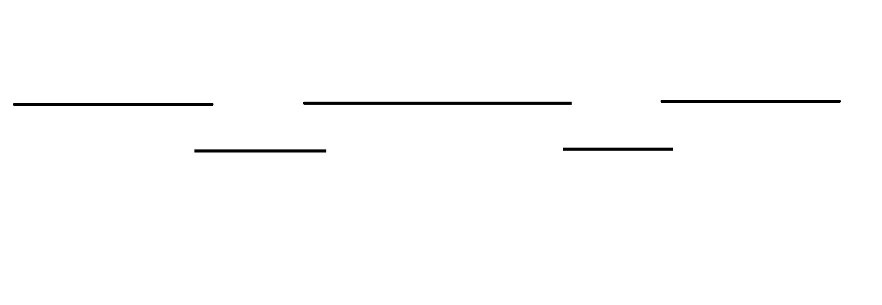

So our algorithm would choose only the two short activities and that wouldn’t be the globally optimal solution (the globally optimal solution would be 3 activities).

1. My code for this problem can be found in “greedy_b.py”.